Guest Lecture Report on "Alkanes"

**Date: 24th September 2024  
Resource Person: Sri V. Peda Ramakrushna, Lecturer in Chemistry, GDC Saluru  
Topic: Alkanes  
Organized by: Department of Chemistry  
Venue: Government Degree College, G.L. Puram**

**The Department of Chemistry, Government Degree College, G.L. Puram, organized a Guest Lecture on the topic "Alkanes" for the Second Year B.Sc. (Hons) Botany students on 24th September 2024.**

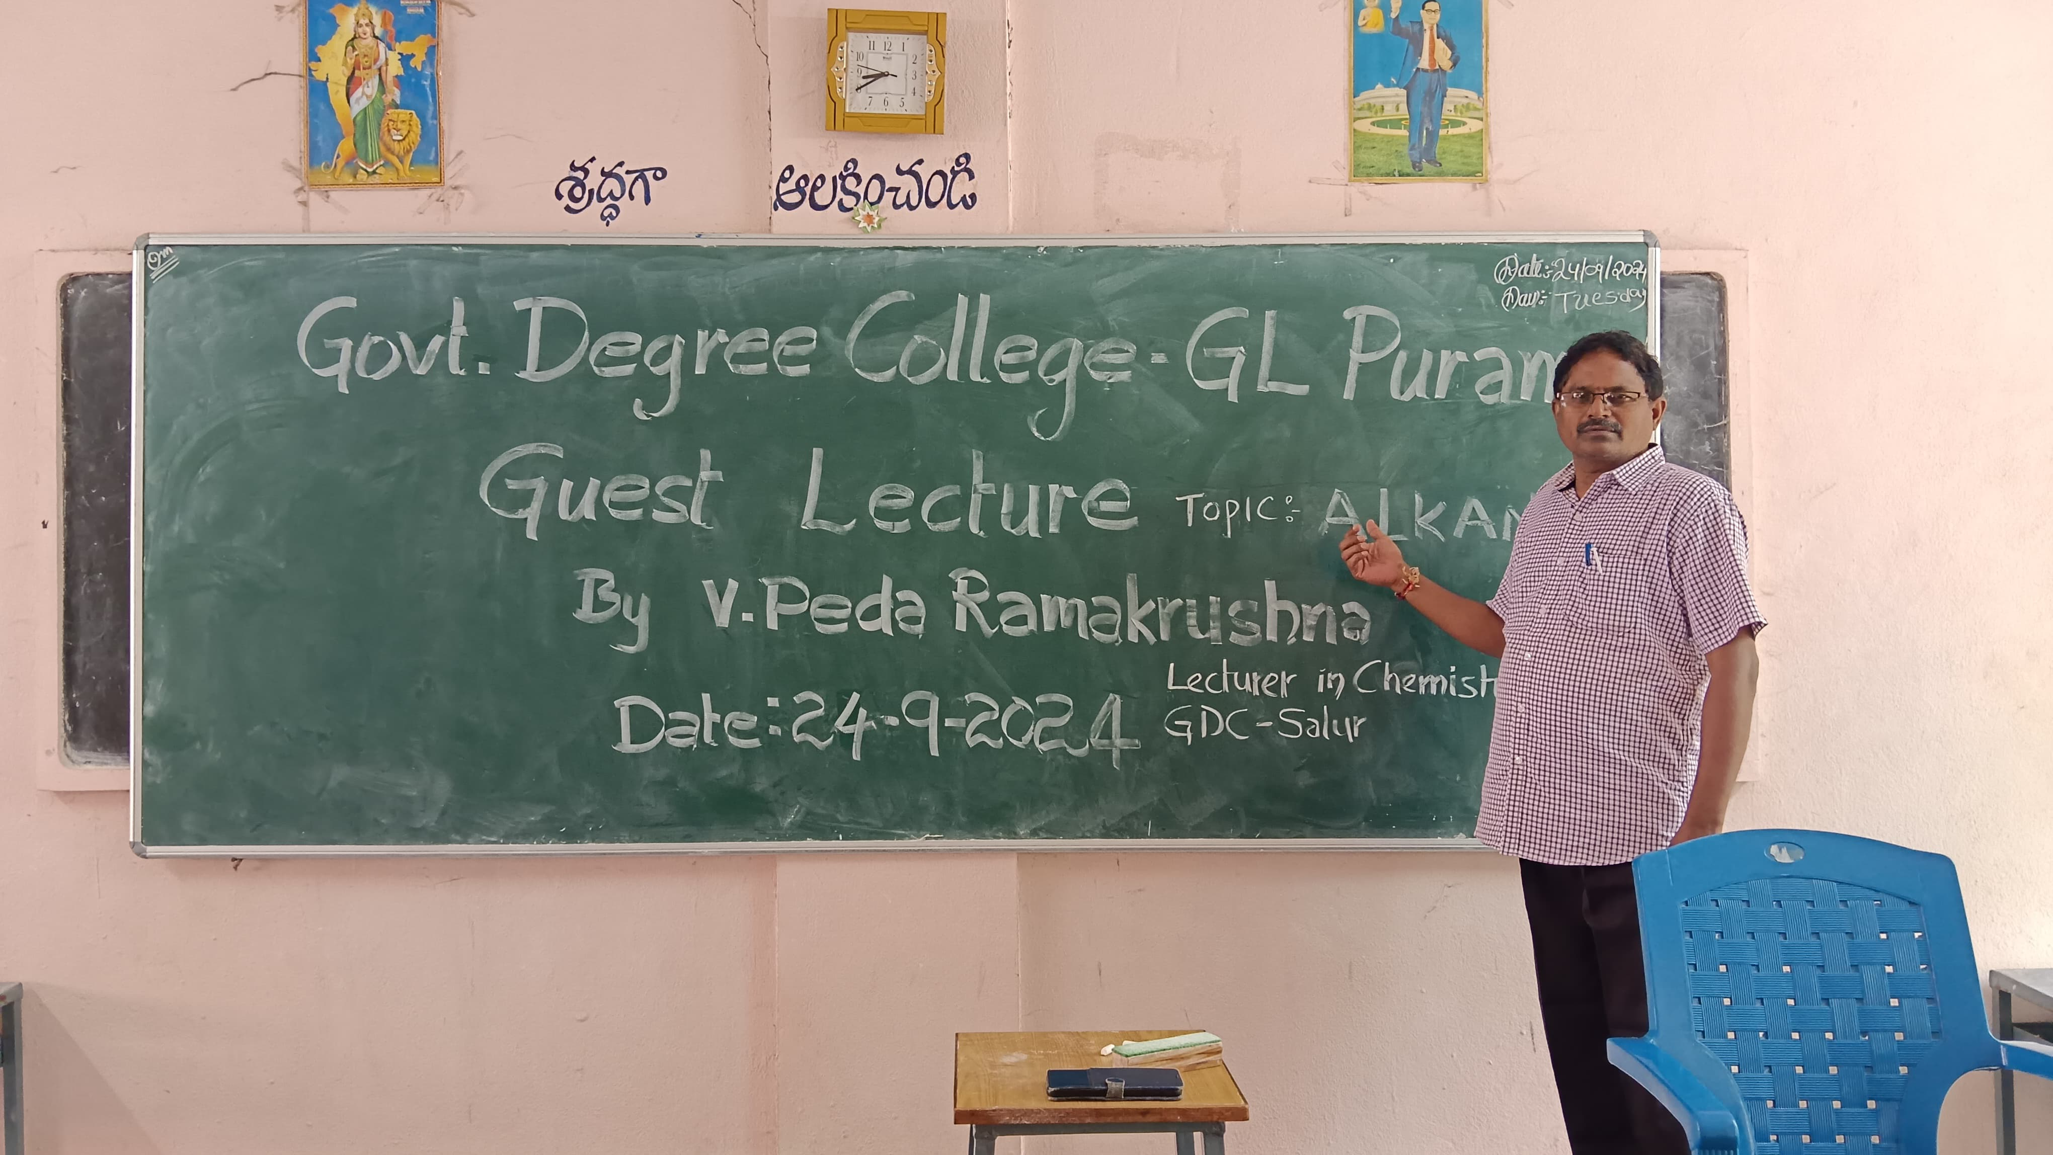

**The lecture was conducted with the kind permission and valuable guidance of Dr. T. Sreevaram, Principal of the college. The event commenced with Sri K. Chinna Rao, Lecturer in Chemistry at GDC G.L. Puram, introducing the esteemed guest speaker, Sri V. Peda Ramakrushna, Lecturer in Chemistry from Government Degree College, Saluru.**

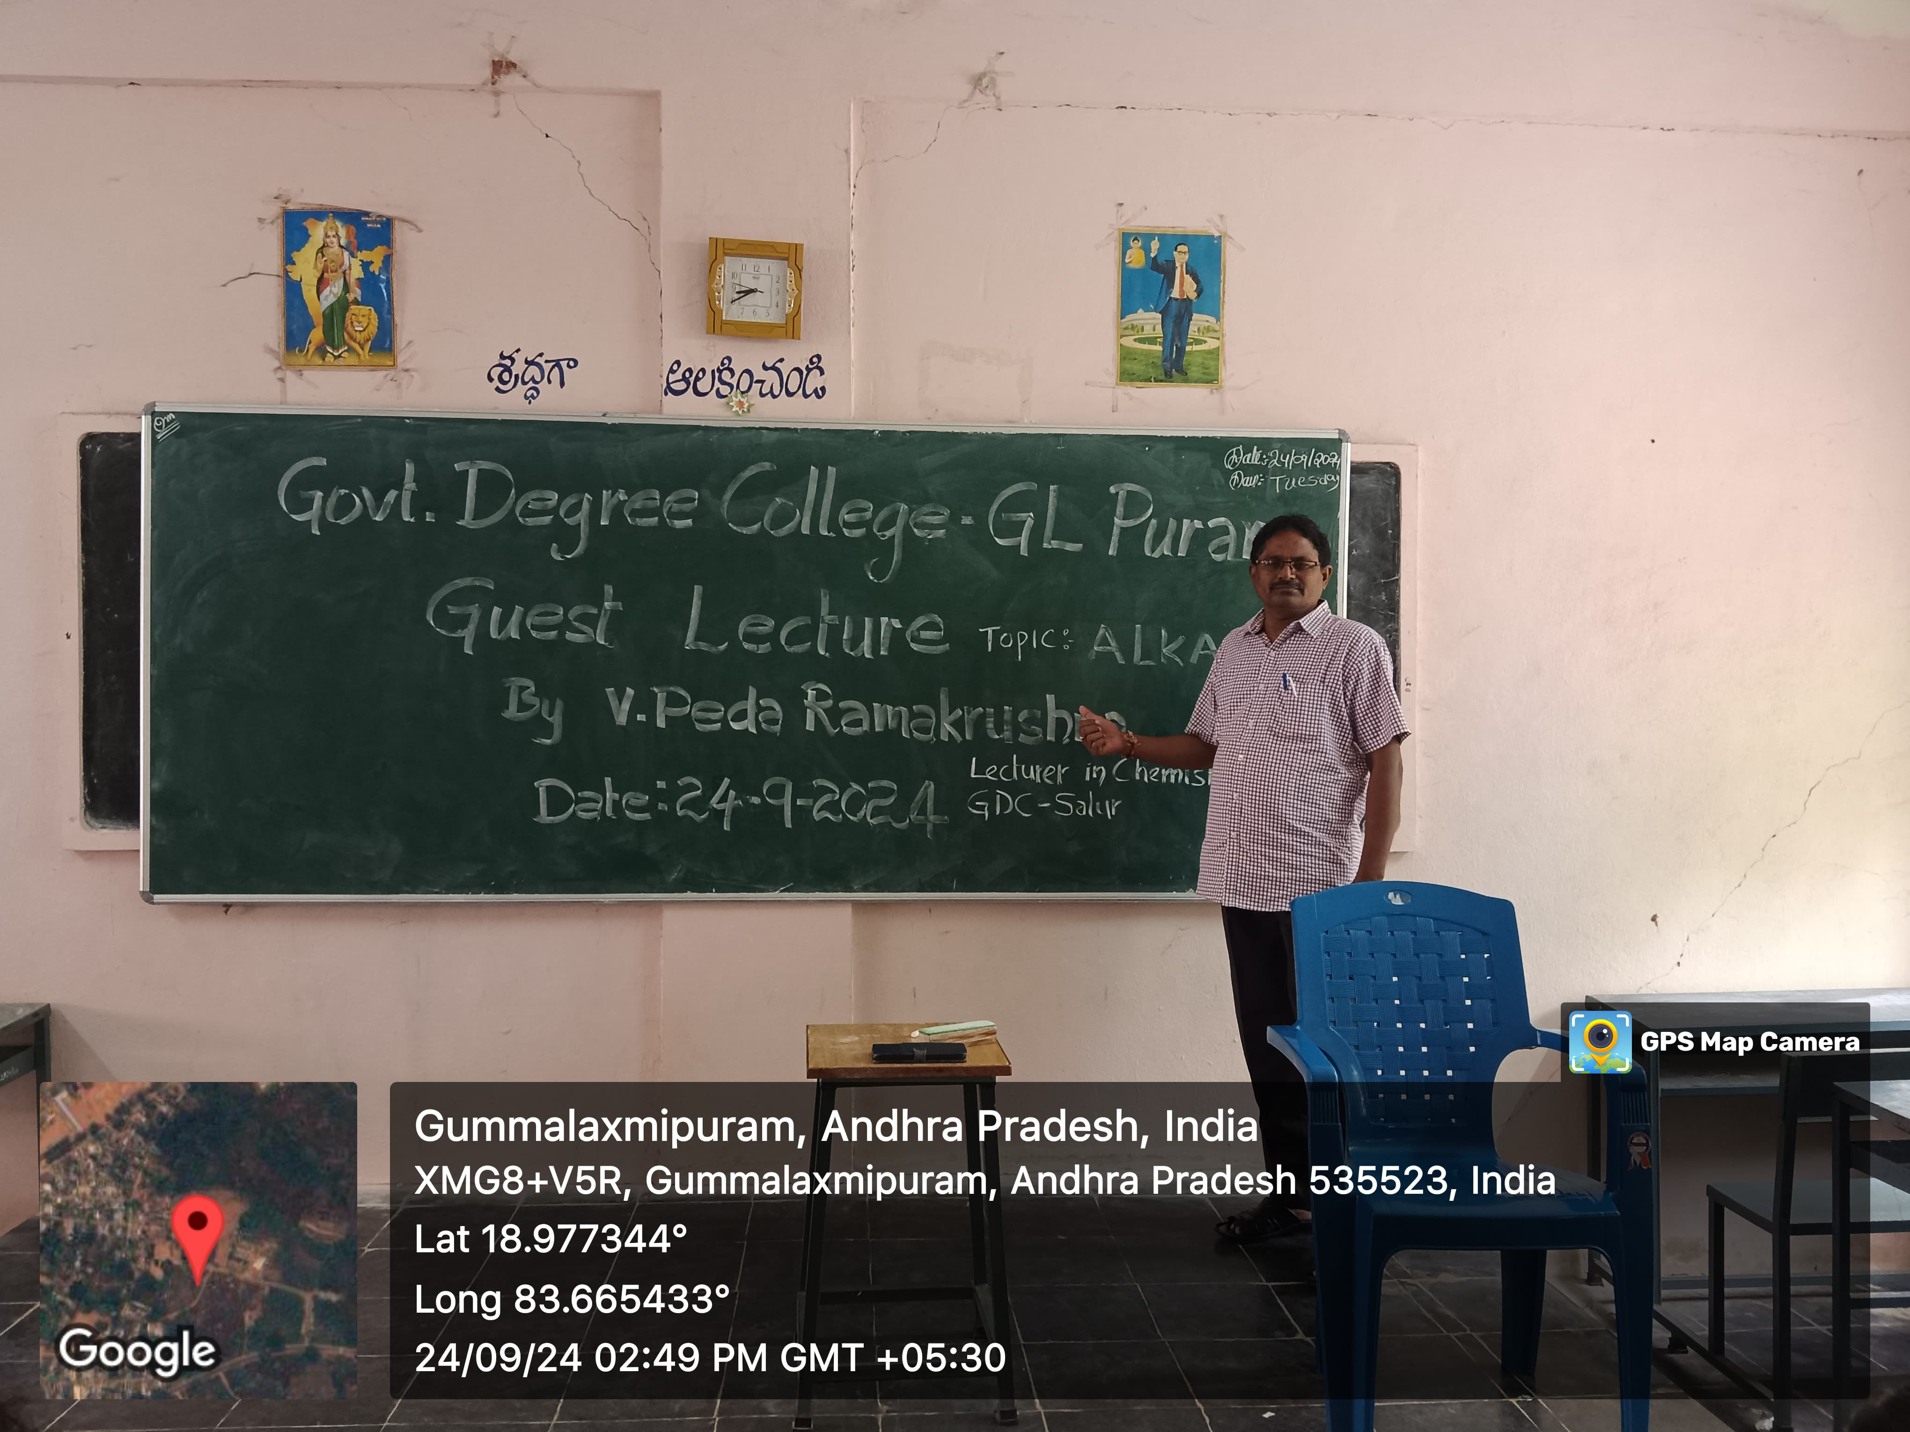

**A total of 30 students participated in the session. Sri V. Pedda Ramakrushna delivered an insightful and detailed lecture on the topic of Alkanes, covering their structure, properties, reactions, and significance in organic chemistry. His effective communication skills, clear explanations, and real-life examples greatly impressed the students, making complex concepts easy to understand.**

**The lecture concluded with a vote of thanks to the resource person for his valuable contribution. Faculty members and students appreciated the effort made by the Chemistry Department in organizing such a fruitful academic session.**

**The event was a resounding success and contributed significantly to enhancing the students' understanding of fundamental organic chemistry concepts.**